This Query generates a country- wise marketing performance report. It groups data by country and calculates the number of unique customers, counts touchpoint from new customer using a case statement, sum successful conversion, total revenue and sorts countries by revenue in descending order.

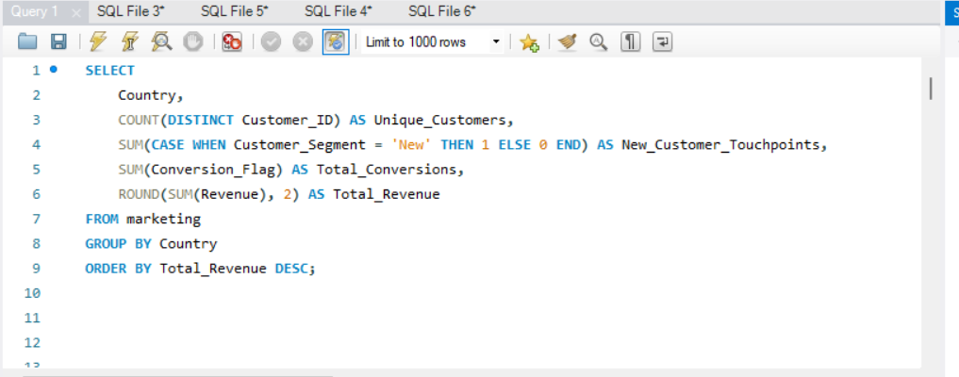
QUERY-;

Solution-;

